**Chapter IV**

**RESULT AND DISCUSSION**

This chapter discusses about the system overview, technical description, structure organization, interpretation of the data gathered through construction and testing of the devices. And the materials, process in constructing the devices.

**System Overview**

The cardiovascular system includes heart. Heart is the organ responsible for pumping blood through human body. Cardiovascular system failure can lead to death. Having a hard time monitoring blood pressure and pulse rate, especially those patient that require immediate treatment once abnormal signs occur like high blood, low blood and high measurement of pulse rate.

The researcher provides a solution to the problem. The study entitled Multi-Functional Monitoring Device for Blood Pressure and Pulse Rate. A personal use monitoring device that will monitor and print blood pressure and pulse rate of the patient.

The component of the device is sensor, microprocessor, LCD display and printer. And a software application for the user profile. The software application designed for multiple user each user has their own profile for the betterment of keeping record without interfering the data of the other users.

The software application also has notification and alarm system features. Notification will be based on the user age. Because normal blood pressure varies depending on the age. The user also can print the result using a printer. Printing form will be consisting of user’s name, the date and time user conducted the reading the result of the reading. This is for the better keeping of records monitoring the blood pressure and heart rate.

**Project Technical Description**

(Statement)

**Block Diagram**

Touch Screen

LCD

Blood Pressure

Sensor

Microprocessor

Printer

Pulse Rate

Sensor

Figure 4.1 **System Block Diagram**

Figure 4.1 shows the interconnection of the main component in the device. The device works when the user attaches the device on his/her arm and fingertip. The sensors were used to detect the user blood pressure and pulse rate and the reading will be transmitted to the microprocessor. The microprocessor receives the data from the sensor for it to process and store. The microprocessor then sends the data to the outputs devices LCD monitor and printer. The LCD displays and also acts as input for the functionalities on device.

**Flow Chart**

Plug in the device

Plug in the device

Click the “Start” button

No

Click “Add Account” button

Do you have an account?

Choose an account

Yes

Create account and click “Submit” button

Attach the armband

Click “Mode” button

Yes

Do you want to set mode?

No

a

Select mode

Click “Save” Button

Reading of blood pressure and pulse rate starts

Click “Start” button

a

Do you want to read healthy tips?

Do you want to print results?

Yes

Click “History” button and see history log

Do you want to see history?

No

No

Yes

Click “Healthy tips” Button

Yes

Click “Print” Button

No

**Fig. 4.2 System Flowchart**

Figure 4.2 shows the system flow of multi-functional monitoring device for blood pressure and pulse rate. The user must plug in the device and press the start button. Then the user must have an account first, if the user hasn’t an account he/she must create an account. Then continue by attaching the arm band. If the user wants to set mode, he/she must click the mode button. The user must choose between the standard mode or by age mode there is another mode which is monitoring mode, if the user chooses monitoring mode, he/she must set interval time. Then the user must click the start button to start the reading of the blood pressure and pulse rate. If the user wants to save the data of blood pressure and pulse rate, he/she must click the save button. Then if the interval time is reach the reading and saving of the blood pressure and pulse rate will automatically start. To stop the monitoring mode the user must click the stop button and the monitoring mode will stop. To see the history the user must click the history button. Then the user can print the output by clicking the print button. If the user wants to read some healthy tips, he/she must only click the healthy tips button. If the user has nothing to do with the device, he/she can shutdown the device.

**Hardware Specification**

The material used in constructing the device was included on this chapter. Names of the material, specification, figure and data sheet are shown below

A. Major Component

**Raspberry Pi 3 Model B**

Raspberry pi is a low cost, credit-card sized computer that plugs into a computer monitor or TV, and uses a standard keyboard and mouse. It is a capable little device that enables people of all ages to explore computing, and to learn to how to program in languages like Scratch and Python. Its capable of doing everything you’d expect a desktop computer to do, from browsing the internet and playing high-definition video, to making spread sheet, word-processing and playing games. Includes a 802.11n WiFi, Bluetooth 4.0, and a quad-core 64-bit ARM Cortex A53 running at 1.2GHz.

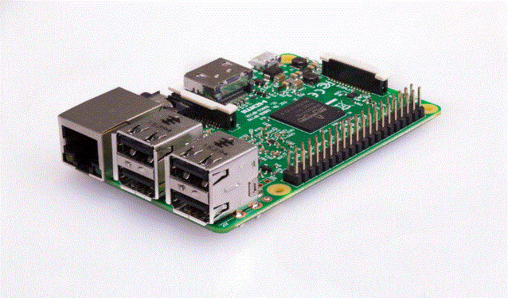  
**Figure 4.3**

**Specification :**

|  |  |
| --- | --- |
| **Chip** | * Broadcom BCM2837 * 64bit * ARMv8 * Quad Core Cortex A53 * 1.2 GHz |
| **Storage** | * microSD Card |
| **Memory** | * 1GB |
| **Graphics** | * 400 MHz Dual Core VideoCore IV GPU * OpenGL ES 2.0 * Hardware-Accelerated OpenVG * 1080p30 H.264 high-profile decode |
| **Weight** | * 42g |
| **Audio** | * HDMI port supports multichannel audio output * Audio line out/3.5-mm headphone jack (analog) |
| **Connections and Expansions** | * Four USB 2.0 ports (up to 480 megabits per second) * HDMI port * 3.5mm 4-pole Composite Video and Audio jack * MicroUSB Power Input * DSI Display Port * CSI Camera Port * MicroSD card Sold * 40-pin GPIO (Male headers) |
| **Communications** | * **Wi-Fi** 802.11n WiFi wireless Networking;IEEE 802.11a/g/b/n compatible * **Bluetooth** Bluetooth 4.1 wireless technology * **Ethernet** 10/100BASE-T Ethernet (RJ-45 connector) |
| **Electrical and Operating Requirements** | * **Input voltage:** 5V DC **Current Requirement:** 2.5 Amps |
| **Operating System** | Raspberry Pi Foundation's Offical supported Operating Systems   * NOOBS * Raspbian   Third Party Operating Systems   * Libreelec * Open Elec * OSMC * Pinet * RISC OS * Snappy Ubuntu Core * Ubuntu Mate * Weather Station * Windows IOT Core * XBia |

|  |
| --- |
|  |

**MPX2050GP Pressure Sensor**

The MPX2050GP silicon piezoresistive pressure sensor providing a highly accurate and linear voltage output, directly proportional to the applied pressure. The sensor is a single, monolithic silicon diaphragm with the strain gauge and a thin-film resistor network integrated on-chip. The chip is laser trimmed for precise span and offset calibration and temperature compensation. And connected to port, which is an input to the on-chip 10-bit analog-to-digital(A/D) converter. The pressure sensor provides a signal output to the microprocessor of approximately 0.2 Vdc at 0 mm Hg to 4.7 Vdc at 375 mm Hg of applied pressure. (plus self explain)

**Specification:**

**Pressure Type:** Gauge

**Pressure Measurement Range:** 0-50 kpa

**Accuracy:** ±1%

**Output:** Analog

**Output Voltage:** 40 mV

**Power Supply:** 5V

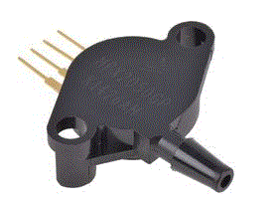

**Figure 4.4 MPX2050GP pressure sensor**

**Pulse Rate Sensor**

This pulse sensor module is used to measure heart rates. It’s widely applied for students, artists, athletes, inventors, games or mobile terminal developers to develop heart rate related interactive works. You can wear the sensor on your finger or earlobe and connect it to Arduino. It also has an open source APP program that can display your heart rate real-time in graph. A heart rate sensor integrated with optical amplifier and noise elimination circuit. Specification: Size: Approx. 1.6*1.6*0.4cm / 0.63*0.63*0.16inch Material: FR-4 Epoxy Resin Glass Fiber Board LED peak wavelength: 515nm Power supply: 3.3V / 5V Output type: Analog Output signal: 0~3.3 (at 3.3V power supply) / 0~5V (at 5V power supply) Package Includes: 1 x pulse sensor module

**Specification:**

* **Voltage:** 3.3V ~ 5 V
* **Current consumption:** 4mA at 5V
* **Diameter:** 16mm
* **Magnification:**  330
* **LED Wavelength:**  609NM
* **Output type:** Analog
* **Output signal:** 0~3.3
* **Material:** FR-4 Epoxy Resin Glass Fiber Board
* **Size:** Approx. 1.6*1.6*0.4cm / 0.63*0.63*0.16inch

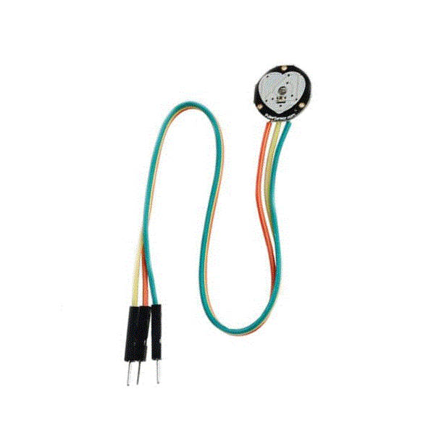

**Figure 4.6 Pulse Rate Sensor**

**ADC ADS1115 (Analog-to-Digital Converter)**

The ADS1115 devices is precise, low power 16-bit, l2C-compatible analog to digital converter (ADCs) offered in an ultra-small, leadless, X2QFN-10 package, and a VSSOP-10 package, The ADS1115 incorporate a low-drift voltage reference and an oscillator it also incorporates a programmable gain amplifier (PGA) and a digital comparator. These feature, along with wide operating supply range, make it well suited for power- and space-constrained, sensor measurement applications. The ADS1115 perform conversion at data rate up to 860 samples per second (SPS). The PGA offers input range from $±$ 256 mV to $±$ 6.144 V, allowing precise large- and small-signal measurements. The ADS1115 features an input multiplexer (MUX) that allow two differential or four single-ended input measurement.

**Specification:**

* Ultra-Small X2QFN Package: 2 mm × 1.5 mm × 0.4 mm
* Wide Supply Range: 2.0 V to 5.5 V
* Low Current Consumption: 150 µA(Continuous-Conversion Mode)
* Programmable Data Rate: 8 SPS to 860 SPS
* Single-Cycle Settling
* Internal Low-Drift Voltage Reference
* Internal Oscillator
* I2C Interface: Four Pin-Selectable Addresses
* Four Single-Ended or Two Differential Inputs (ADS1115)
* Programmable Comparator (ADS1114 and ADS1115)
* Operating Temperature Range: –40°C to +125°C

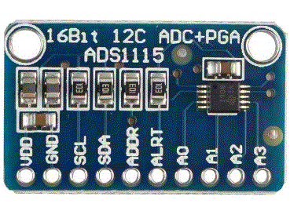

**Figure 4.5 ADC ADS1115 (analog-to-digital converter)**

**DC 6V Solenoid Valve**

DC 6V Solenoid Valve is an [electromechanically](https://en.wikipedia.org/wiki/Electromechanical) operated [valve](https://en.wikipedia.org/wiki/Valve). The valve is controlled by an [electric current](https://en.wikipedia.org/wiki/Electric_current) through a [solenoid](https://en.wikipedia.org/wiki/Solenoid): in the case of a two-port valve the flow is switched on or off; in the case of a three-port valve, the outflow is switched between the two outlet ports. Multiple solenoid valves can be placed together on a [manifold](https://en.wikipedia.org/wiki/Hydraulic_manifold).

Solenoid valves are the most frequently used control elements in [fluidics](https://en.wikipedia.org/wiki/Fluidics). Their tasks are to shut off, release, dose, distribute or mix fluids. They are found in many application areas. Solenoids offer fast and safe switching, high reliability, long service life, good medium compatibility of the materials used, low control power and compact design.

Besides the plunger-type [actuator](https://en.wikipedia.org/wiki/Actuator) which is used most frequently, pivoted-armature actuators and rocker actuators are also used.

**Specification**

**Voltage:** DC6.0V

**Current:** < 380mA

**Bleed rate:** < 3S (air pressure in 500cc container to 300mmHg - 15mmHg)

**Pressure range:** 0-350mmhg

**Sealing:** 500CC container inflation pressure from 0 to 300 mmHg after the end of the inflation, stable 30 seconds after the test to reduce the pressure value is less than 5mmHg/min.

**Using fluid:** AIR air

**Service life:** 500CC container, 10 seconds for 5 seconds to 50000 seconds for a loop test.

**Use temperature range**: 0-5cm,30cm(60dB)

**Power:** < 2W

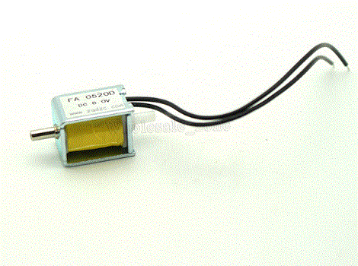

**Figure 4.7 DC 6V Solenoid Valve**

**Connecting Wires(male-to-male, female-to-male and female-to-female)**

Handy for making wire harnesses or jumpering between headers on PCB's. These premium jumper wires are a little over 6" (150mm) long and come in a 'strip' of 40 (4 pieces of each of ten colors). They have 0.1" sockets on either end and fit cleanly next to each other on standard-pitch 0.1" (2.54mm) header. We recentlty updated these so they are in a 'ribbon strip' instead of individual wires. You can always pull the ribbon wires off to make individual jumpers, or keep them together to make neatly organized wire harnesses

**Specification:**

* Material: durable hard plastic and copper wire.
* Cable length: about 20cm.
* Connectors: 1pin-1pin male to female header, female-to-female and male-to-male.
* Compatible with 2.54mm spacing pin headers.
* Perfect for electronic projects.

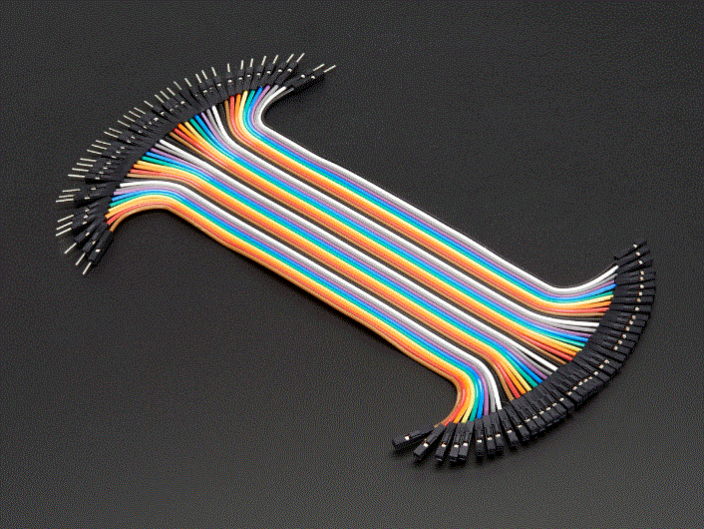

**Figure 4.8 Connecting Wires**